Nick Xinyuan Li May 2, 2024

Videogame Design and Critique | CMAC 755S Final Document

**Design Decisions Explanation**

**Choice of mechanics and interactions**

I made a hunger mechanic and a currency mechanic in this demo, and created an NPC interaction mechanic with the help of plugins. The first two are of great concern as a low tier artist, representing size and income. The vending machine scene where the player uses currency for the first time also creates a city atmosphere. The interaction mechanism with NPCs is kind of a response to the booming AI, and it also lets the player feel the feeling of freely interacting with others as an artist. The arrangement of the NPC as the player's roommate here also hints at the economic status of the two.

**Art style and aesthetic direction**

While not calling it art, this screenshot is a better representation of the atmosphere I was trying to create. Narrow alleys, neon lights, vending machines, these are all elements that make up this neighborhood of this virtual city.

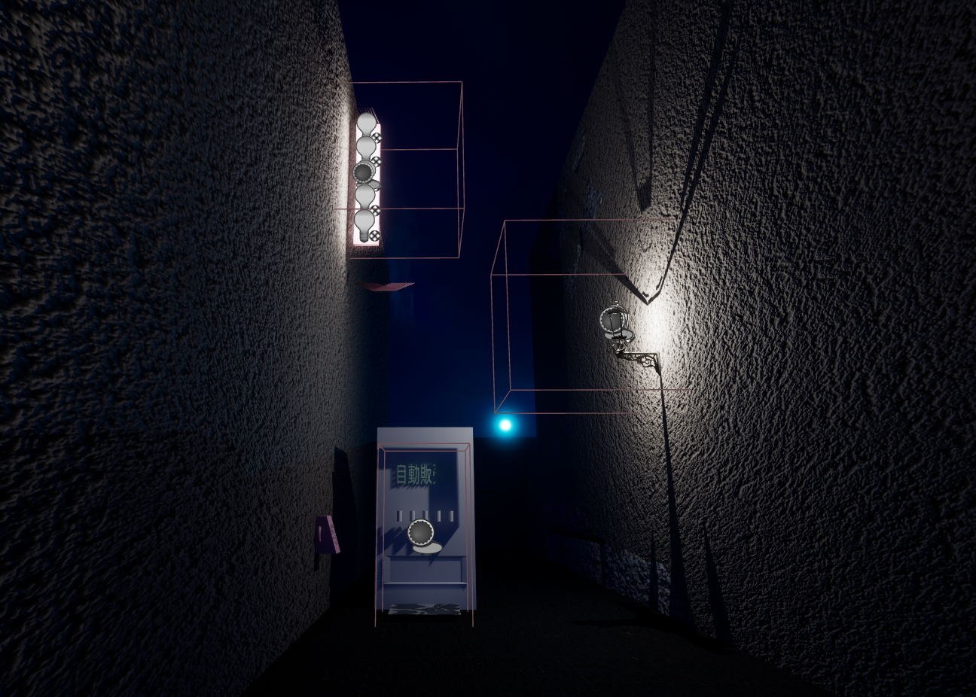

**Lighting and sound design choices**

Lighting is relatively easy to design for dark scenes. In my demo, placing a street light (spot light) or a long lamp (rectangular light) at or near the exit will guide the player. Sound effects are not available yet, partly because they are relatively minor for my theme.

**Challenges**

The most significant challenge encountered so far is performance optimization. As shown in the screenshot, the NPC's hair is not rendered when they are observed from a distance. There's also a lack of materials for the models I'm modeling myself, as my skills don't allow it at the moment.

**人站在桌子上

**

**Reflection**

**Most Enjoyable and Valuable Aspects**

I appreciate the integral approach to learning about game design. The inclusion of different modules on the history of video games, game mechanics, and the game design process provides a solid foundation for me understanding how games are conceived, developed, and received by the audiences. Assignments like "Play Like a Designer" and "World Building Paper" are particularly valuable because they not only encourage creativity, but also critical thinking about how to make game mechanics effective and engaging.

**Areas of growth or improvement**

The course facilitated my substantial development in several key areas of game design. For example, narrative creation focused on improving meaningful gameplay is critical for anyone who wants to make games that are not only fun but also narratively engaging. The opportunity to critique the work of fellow students and receive feedback is another important aspect, as it promotes a deeper understanding of one's own work and the ability to make improvements based on constructive criticism.

**Lessons and skills**

I consider myself more or less fully equipped with skills in game design upon completion of the program, including narrative development, character creation, and technical aspects of game building. I agree that problem solving and teamwork skills are emphasized to prepare students for realistic scenarios where collaboration and adaptive skills are just as important as technical skills.

**Future Aspirations**

I believe the skills and insights I have gained from this course have inspired a desire to further explore game design. This experience has also inspired me to pursue professional interests in areas such as AI in games or advanced narrative techniques to push the boundaries of game design and experience.

**Credits and Acknowledgments**

This project uses the following from the Marketplace:

* ConvAI,
* Edith Finch,
* Free Furniture Pack,
* Necro's Utility Material Pack,
* Quixel Bridge contents,
* Scanned 3D People Pack.

The soundtrack used was “1000 Knives" by YMO.

Acknowledgement to Hilary N. Huskey, Instructor of the Videogame Design and Critique course, and all of my classmates. I was able to complete this project thanks to their guidance or advice.